Notes :

By default, every thing is proteced in spring security Even for non-existing urls if defualt security is enabled they are under spring secuirty. Spring secuirty after authentication only will tell weather if they are existing.

Spring secuirty by default provide login form logout form (form based authetication)

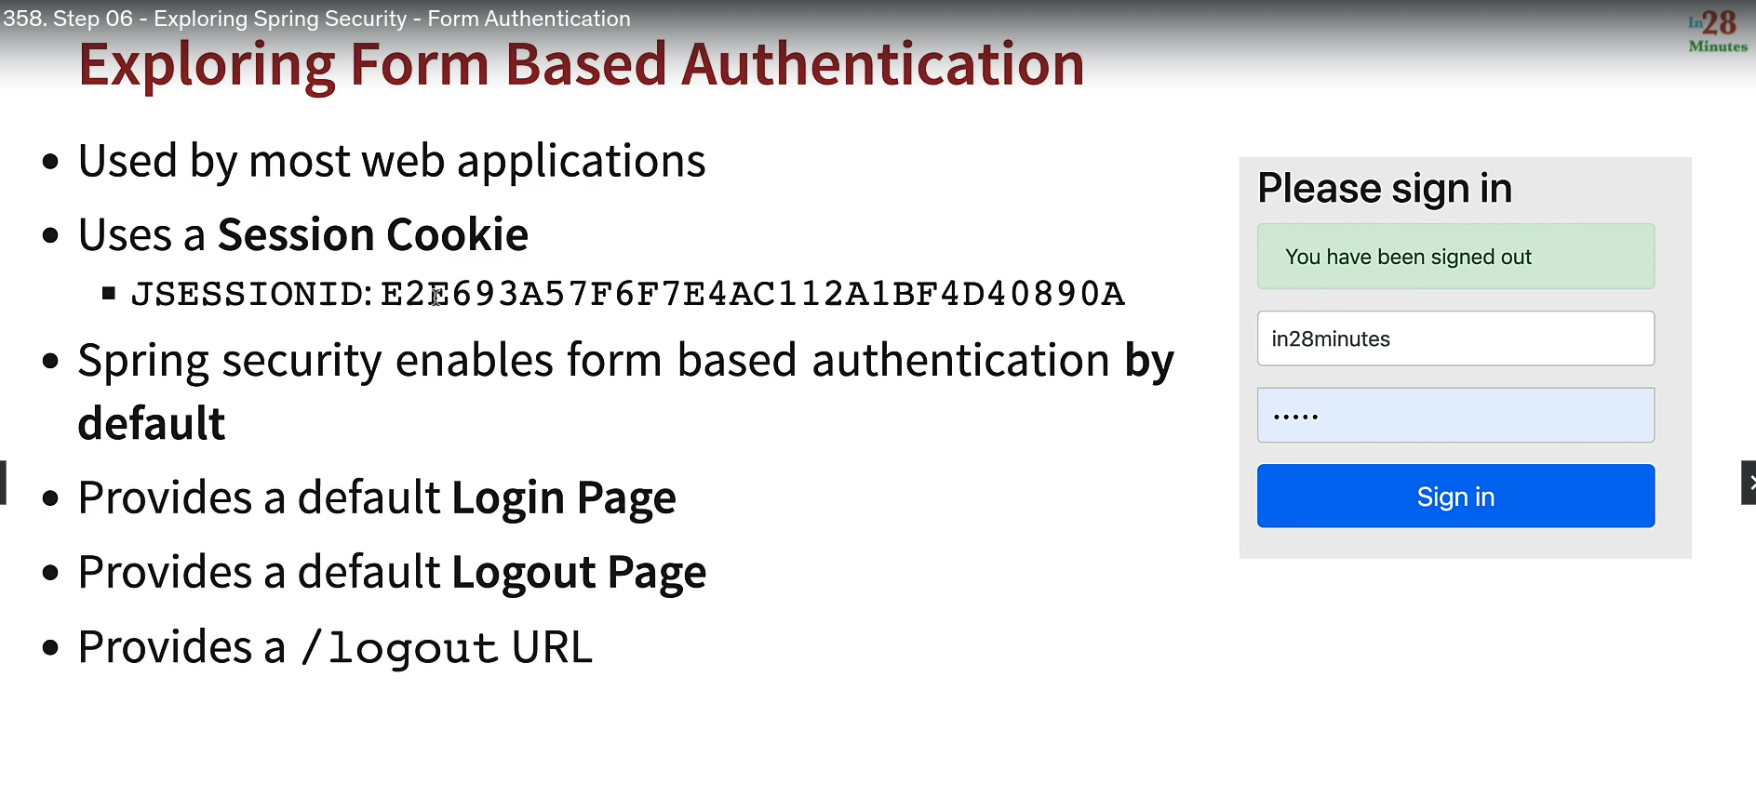

Spring secuirty Filter intercept request even before Dispatcher servelet (which handle all the request.)

basic authenication is not secured as it uses base 64 enconding

1. which can be decode easliy
2. it not have any expiry 